**Project design phase - Ⅱ**

**Data flow diagram and user stories**

|  |  |
| --- | --- |
| Team id | **PNT2022TMID12064** |
| Project name | Fertilizer recommendation system for disease prediction |
| Maximum marks | 4 marks |

**Data flow diagram:**

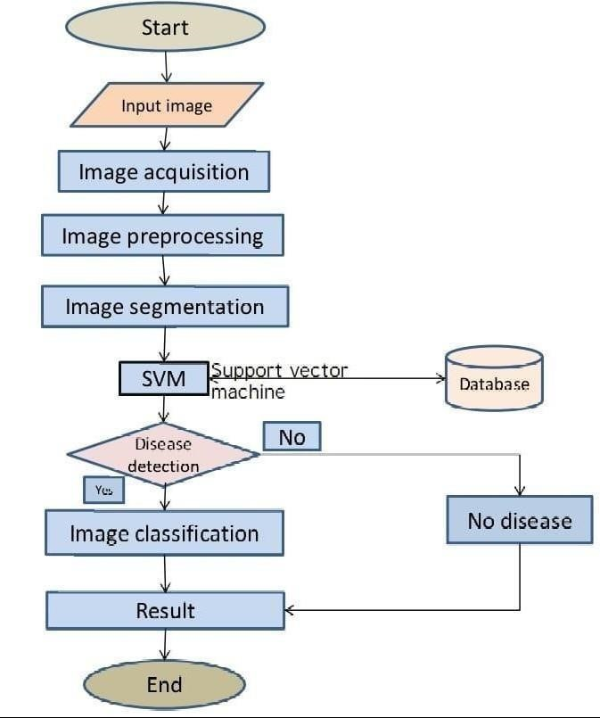

**User Stories :**

|  |  |  |  |  |  |  |
| --- | --- | --- | --- | --- | --- | --- |
| **User Type** | **Functional**  **Requirement (Epic)** | **User Story Number** | **User Story / Task** | **Acceptance criteria** | **Priority** | **Release** |
| Custo mer (Mobile user) | Registration | USN-1 | As a user, I can register for the application by entering my email, password, and confirming my password. | I can access my account / dashboard | High | Sprint-1 |
|  | Login | USN-2 | As a user, I can log into the application by entering email & password | I can login using my E-mail ID  accounts or user credentials | High | Sprint-1 |
|  | Dashboard | USN-3 | As a user, I can view the page of the application where i can upload my images and the fertilizer should be recommended | I can access my account/ dashboard | High | Sprint-2 |
| Customer (Web  user) | Registration | USN-4 | As a user, I can login to web dashboard just Like website dashboard | I can register using my username and password | High | Sprint-3 |
|  | Login | USN-5 | As a user, I can login to my web dashboard with the login credentials | I can login using my  User credentials | High | Sprint-3 |
|  | Dashboard | USN-6 | As a user, I can view the web application where i can upload my images for getting the suggestion of the fertilizer | I can access my account/ dashboard | High | Sprint-4 |
|  |  | USN-7 | As a user, the fertilizer recommended to me Is in high accurate | I can access my account/ dashboard | High | Sprint-4 |
| Administrator | Login | USN-8 | As a admin, I can login to the website using my login credentials | I can login to the website using my login credentials | High | Sprint-5 |
|  | Dashboard | USN-9 | As a admin, I can view the dashboard of the application | I can access my dashboard | High | Sprint-5 |